Sprint 2 Plan: Price Your Playlist

Goal

Implement Spotify OAuth authentication and playlist retrieval so that the users can log in to the PYP site using their Spotify account and be able to view their playlists.

Tasks
● User Story 1(“As a user, I want to be able to log in to the PYP site”): ○ Build demo login page on React Frontend (2hrs)
○ Handle OAUth callback and store access tokens (1hr)
○ Set up Spotify OAuth flow and API credentials in the backend (2hrs) ■ Total for User Story: 5 hours
● User Story 2(As a user, I want to be able to see my playlist after logging in with my Spotify account):
○ Fetch the users playlist data from Spotify API in the backend (2hrs) ○ Pass playlist data from Flask backend to the React Frontend (1hr) ○ Display playlist names and the cover art on frontend UI (2hrs)
■ Total for User Story: 5 hours
● User Story 3(“As a tester, I want to verify that logging in successfully retrieves and displays the correct playlist”)
○ Write test cases for Spotify login flow (1hr)
○ Try to verify that the playlist data matches the user’s actual Spotify account (1 hr) ○ Document and report the test results of the program (1 hr)
■ Total for User Story: 3 hours

Team roles
○ Richard: Developer
○ Kaan: Developer
○ Vanessa: Developer
○ Victor: Developer, Scrum Master
○ Abner: Developer

Initial task assignment
○ Richard: User Story 2, Try to hook up Spotify backend logic to React frontend
○ Kaan: User Story 1, set up the Spotify OAuth and build demo login page
○ Abner: User Story 2, Discogs API integration as well as pricing demo
○ Vanessa: User story 2, frontend playlist display
○ Victor: User Story 3, verify the login and the playlist retrieval

Initial burnup chart

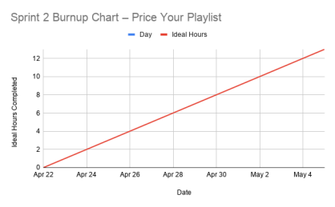
Initial scrum board
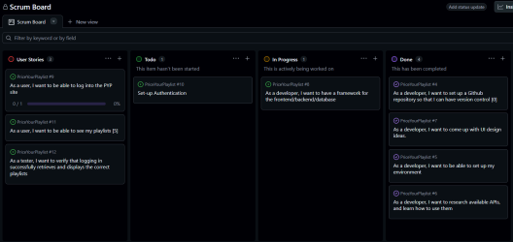

Scrum times
  - Tuesdays at 11:00am – Team Scrum Meeting (TA)
  - Tuesdays at 4:00pm – Team Scrum Meeting (McHenry Library / Discord)
  - Thursdays at 4:00pm – Team Scrum Meeting (McHenry Library / Discord)
  - Wednesdays during class Time – Scrum Meeting

